Roll no: 2019BTECS00022

Name: Prachi Rameshkumar Chobhare

Topic: Python file and exception handling

Q.1

f=open("my_folder.txt","a")

f.write("Good Day ")

f.close()

f=open("my_folder.txt","r")

print(f.read())

f.close()

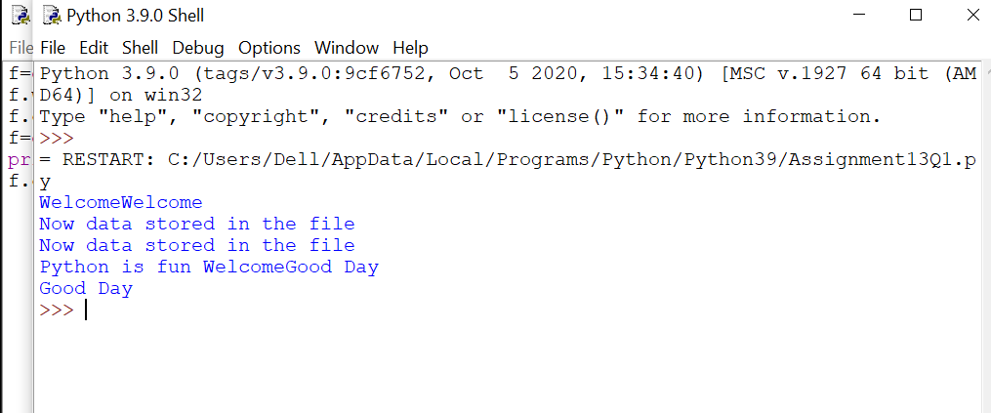

Q.2

try:

print(1+1)

print(sum)

print(6/4)

except NameError:

print("Sum does not exist")

except ZeroDivisionError:

print("Cannot divide zero")

except:

print("something went wrong")

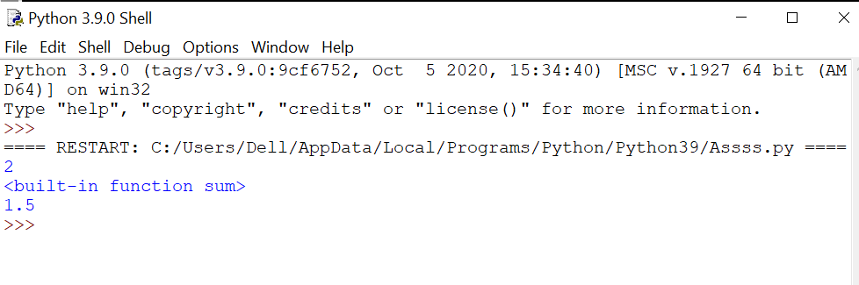

try:

print(1+1)

print(sum)

print(6/0)

except NameError:

print("Sum does not exist")

except ZeroDivisionError:

print("Cannot divide zero")

except:

print("something went wrong")

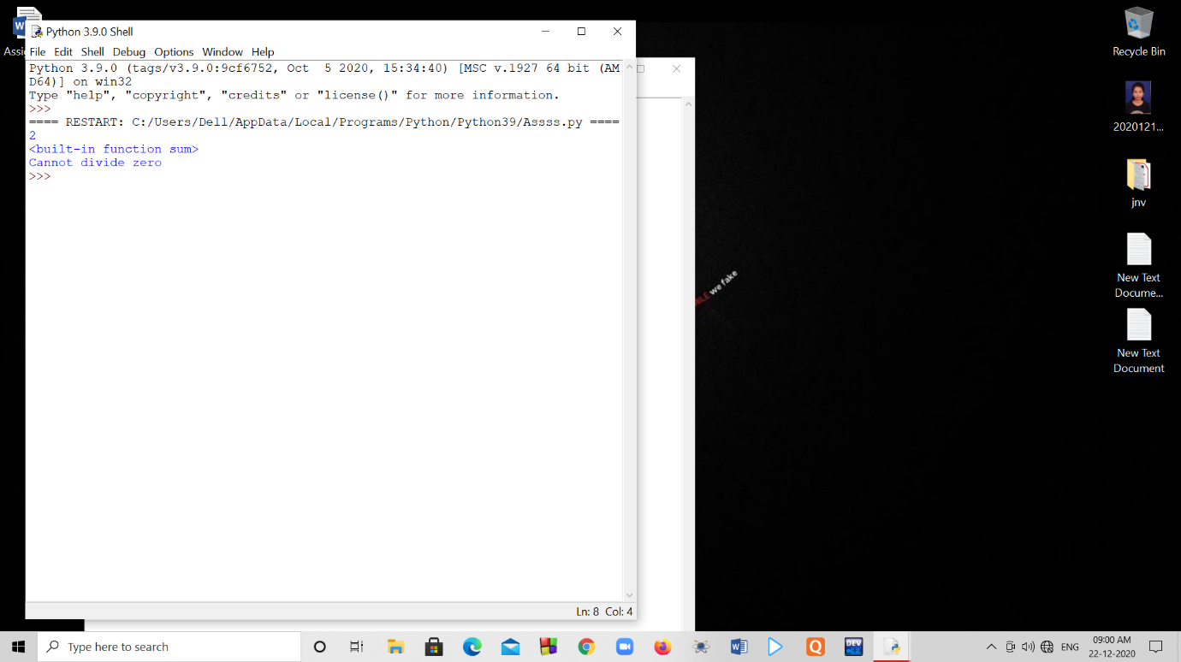

Q.3

//Dividing by zero

def divide(x,y):

try:

result=x//y

except ZeroDivisionError:

print("Sorry ! You are dividing by zero")

else:

print("Yeah !your answer is :",result)

finally:

print('Programm end ')

divide(6,0)

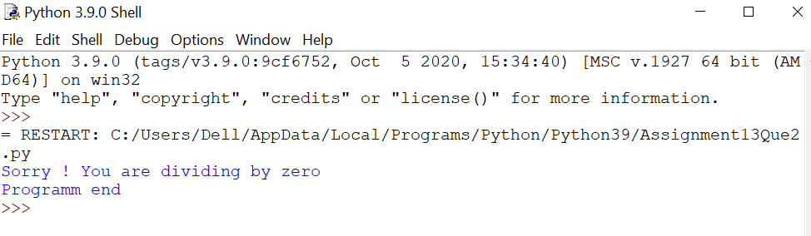

//dividing by other number

def divide(a,b):

try:

result=a//b

except ZeroDivisionError:

print("Sorry ! You are dividing by zero")

else:

print("Yeah !your answer is :",result)

finally:

print('Programm end ')

divide(6,2)

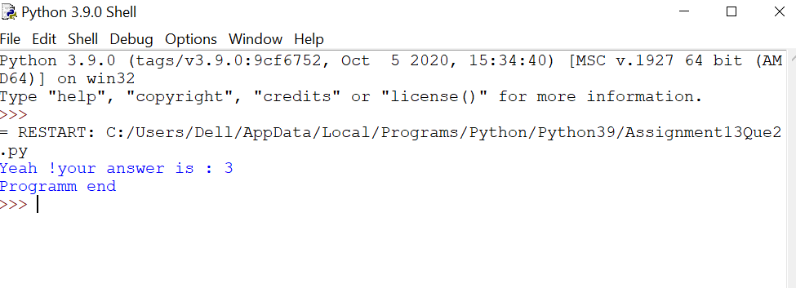

Q.4

string='Bye'

if string=='Hello'or string=='Hi'or string=='Bye':

raise Exception("This Words Are not allowed")

else:

print(string)

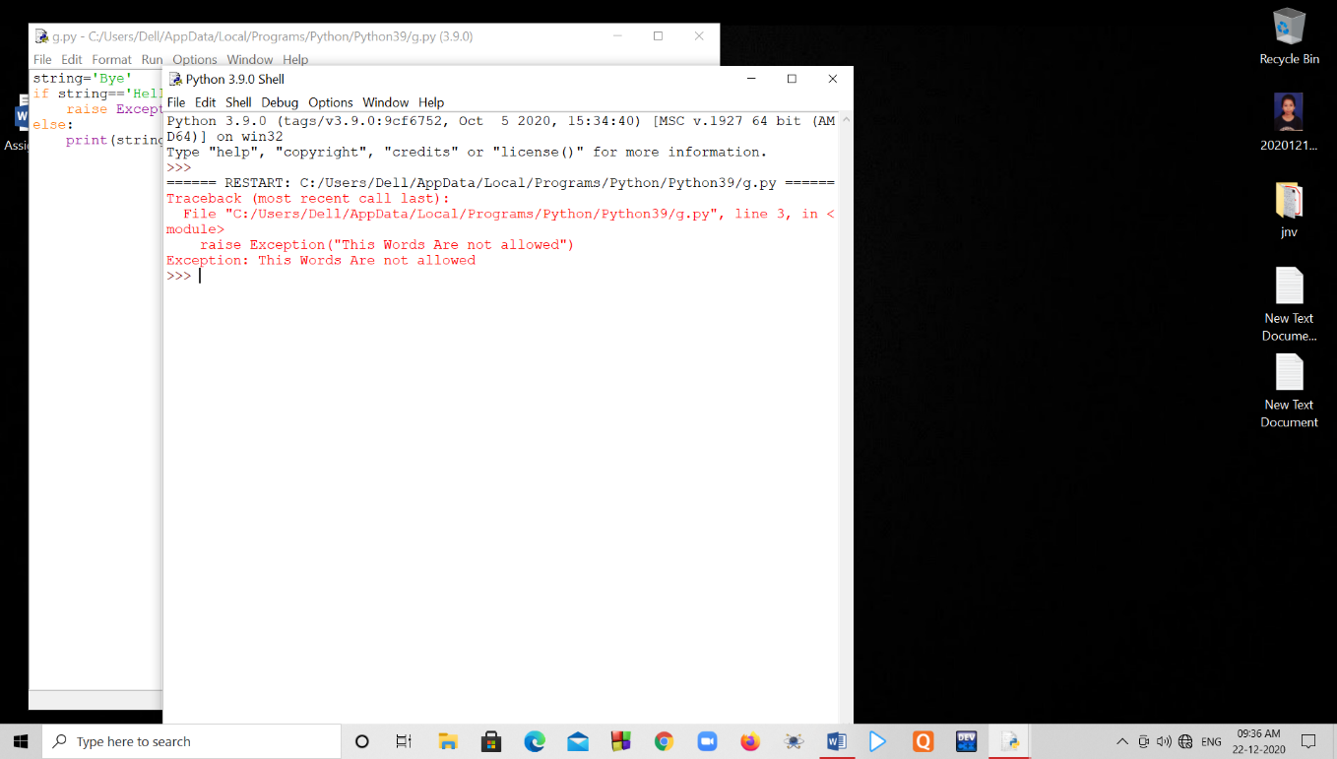

string=”Good morning”

if string=='Hello'or string=='Hi'or string=='Bye':

raise Exception("This Words Are not allowed")

else:

print(string)

